8th Grade Science- Uddo Name: ________________________________________
Plate Tectonics Guided Notes

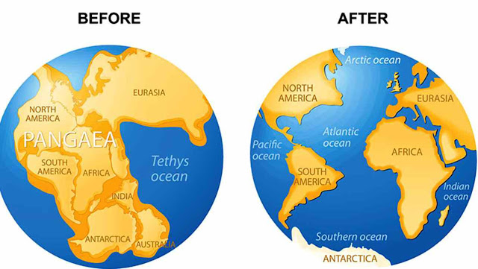
Continental Drift
Alfred Wegener (1910)
- Hypothesized that all the ________________ were once joined
together in a single landmass called _______________ and have
since drifted (like __________ ___ ___________)
  - This became known as _________________
_________________
  - ________________- supercontinent
(existed 350-200 million years ago)
  - (Pangaea means “all lands” in latin)
  - Others had similar ideas, however Wegener was the first to have scientific
___________________ to support this idea

Evidence for Continental drift
- ________________________ features
    - _______________ of some continents seemed to fit together like a ______ ______ _______________
    - Mountain ranges in ____________________ line up with those in ____________________
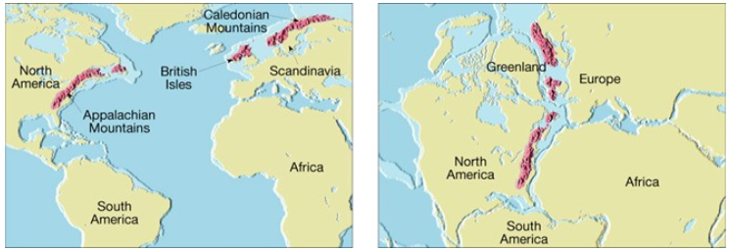

2.) _______________________-- any trace of an ancient organism that is preserved in rock

    - Glossopteris- fern like __________ with leaves the shape of a tongue, lived 250 million years ago
      - Found in ______________, South America, Australia, __________ and Antarctica
      - These land masses are now separated by oceans indicating that____________ once existed

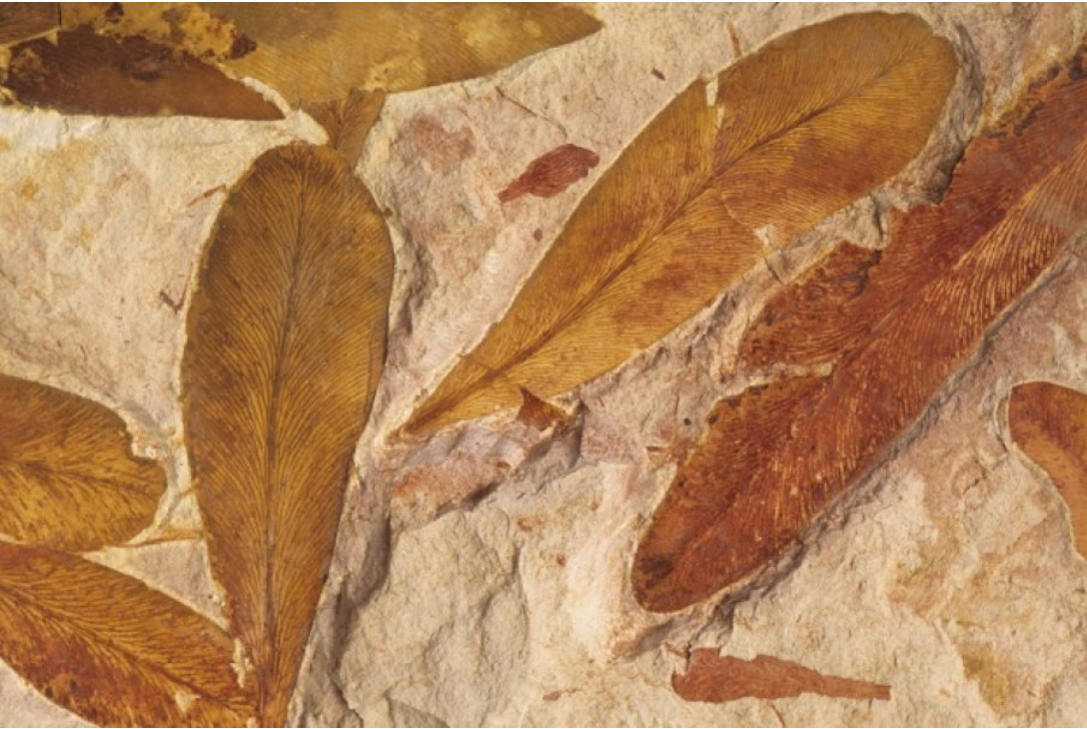
    - Mesosaurus and Lystrosaurus- fresh water ________________
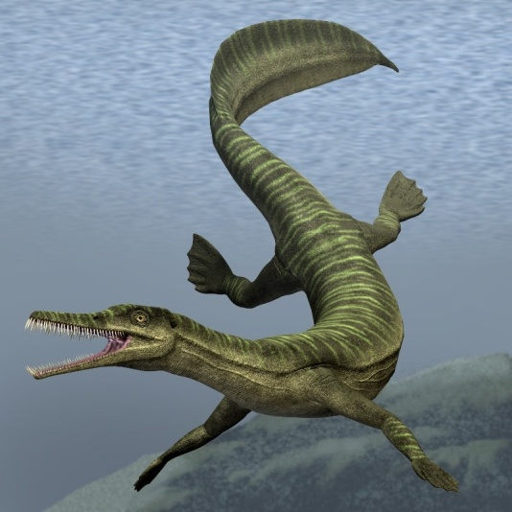
      - Fossils found in places separated by _____________
        - Neither reptile could have swum that great of
a distance in salt water
        - Explanation: ___________________________
______________________________________
______________________________________
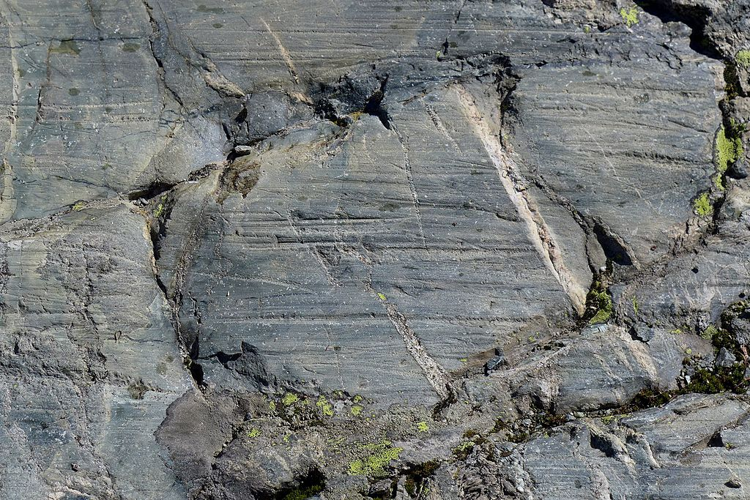
3.) _______________________

- Fossils of _____________l plants found on an island in the arctic ocean

- Scratches in rocks made by _______________ found in South Africa

- ______________ fields in Europe and North America lined up
    - Coal only forms in _____________, _____________ areas

****When _______________ move, north or south, they take the ______________ and rocks that formed in the past with them

Continental Drift—_________________________

  - Wegener provided supporting _____________________ to the continental drift theory

BUT….

Could not identify the _____________________ that cause the plates to __________________ (the force that caused the push or pull) because of this, most geologist rejected his theory

Eventually, continental drift EVOLVES into ______________ __________________________

The Theory of Plate Tectonics

- Plate- A section of the ___________________ that slowly moves over the _________________, carrying pieces of continental and oceanic crust

- ____________________-breaks in the Earth’s crust where rocks have slipped past each other, form along these boundaries

- Theory of Plate Tectonics- Earth’s plates are in slow, constant motion, driven by _______________ ________________ in the mantle.

- Convection current –A flow of material caused by _______________________ differences

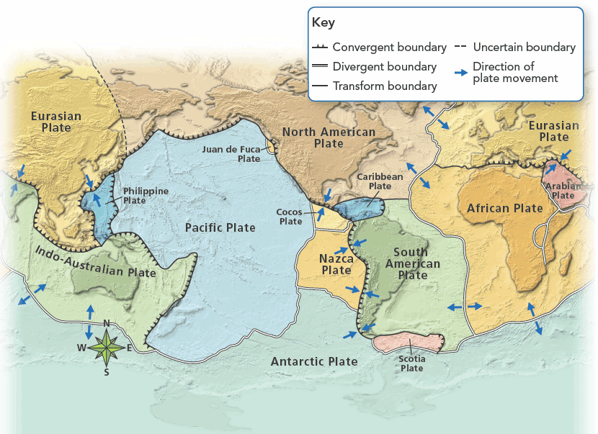

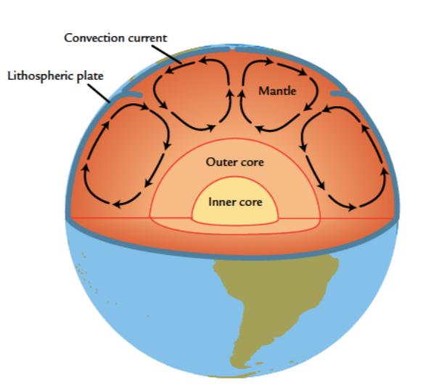
Convection Currents
- Occurs in the ________________________ of the mantle

How Convection Works:
- Heat from Earth’s core causes the material of the mantle to become a
_______________ ______________ solid (it can stretch and “flow”)

- Once heated the material becomes less ______________ so it rises toward the Lithosphere

- At the rigid ______________________ it cannot move upward any more so it moves to the right or the left

- As it moves, it drags the lithospheric ________________ with it and cools.
  - The material becomes ____________________ dense and it sinks back toward the core

- The above process is repeated.
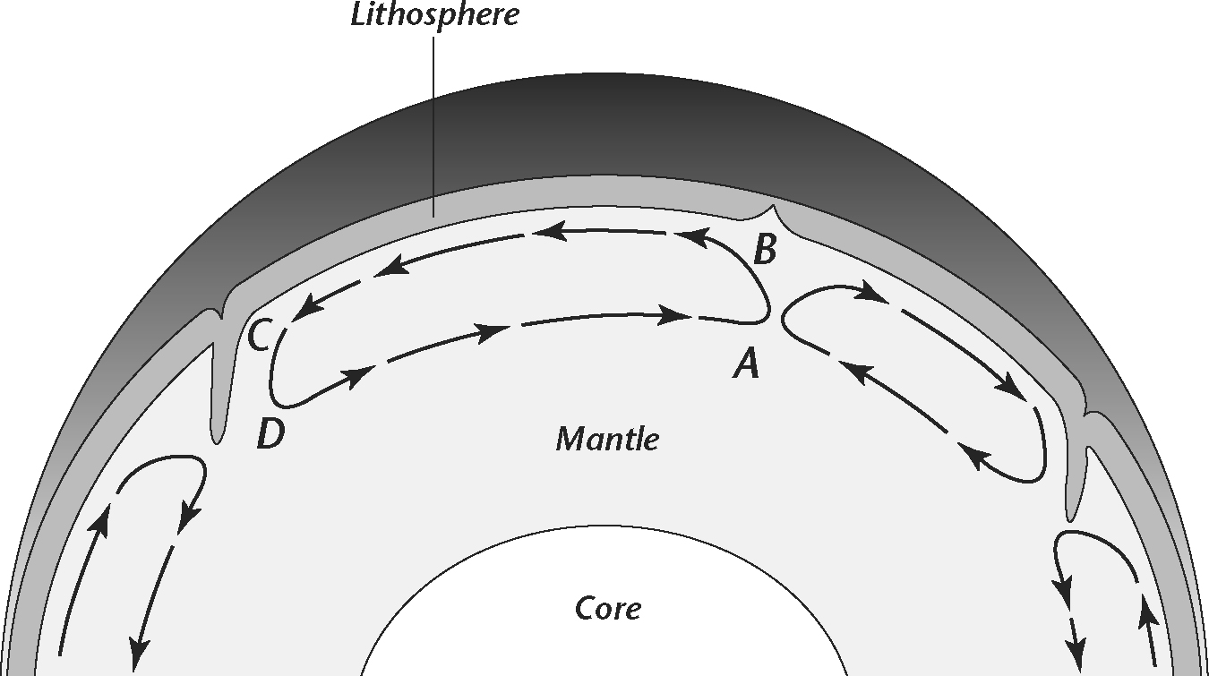

Convection Current Practice- Use the diagram to the right to answer the
following questions
- Where is the temperature of the mantle material
greater, at point A or point B? Explain why. _________________
____________________________________________________
____________________________________________________

- Where is the density of the material greater, at point B or
point C? Explain why. _________________________________
___________________________________________________________________________________________

- What causes the convection cell to turn to the left at point B? ___________________________________________________________________________________________
___________________________________________________________________________________________

- What happens to the temperature and density of the material between point B and C? ___________________________________________________________________________________________

- What force causes the convection cell to turn at point C? ___________________________________________________________________________________________
___________________________________________________________________________________________

- What happens to the temperature and density of the material between points D and A? ___________________________________________________________________________________________

- What causes the convection cell to turn up at point A? ___________________________________________________________________________________________
___________________________________________________________________________________________

- How do you think this convection cell might affect the crustal material above it? ___________________________________________________________________________________________
___________________________________________________________________________________________

- What would happen to convection if the heat source was removed? __________________________________________________________________________________________
Measurement of plate motion over time
- _______________________ are used to measure plate motion precisely.

  - Plates move constantly and slowly - between 1-12 cm per year

    - North American and Eurasian plate move about _____________________

      - FOR SCALE : This is about the same speed in which your __________________ grow

    - Although very slow, the plates have been moving for hundreds of millions of years so they have moved ________________ ___________________.

Since the breakup of Pangaea, the continents have taken about ___________ ___________ __________ to move to their present location.

200 million years ago 115 million years ago Earth Today
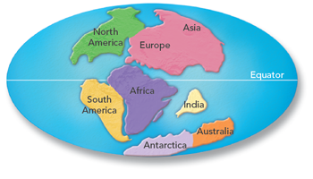
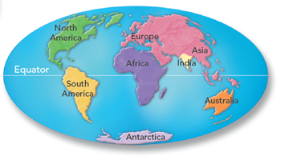
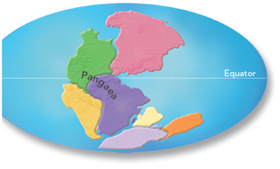

- As the plates move, they create ____________________, volcanoes, mountain ranges and ______________ ____________________ ____________________

3 Types of Plate Boundaries

1.) Divergent Boundaries-two plates slowly move ___________________ from each other

  - In the ocean = ____________ ________________ _________________ (________________)

    - Underwater __________________ ranges

    - new crust is added during process of ___________ _______________ ____________________

      - ex. Mid Atlantic Ridge, Atlantic Ocean

  - On land = _______________ _____________________

      - ex. East ________________ Rift System, Africa

Sea Floor Spreading- the process by which molten material adds _________ _________ crust to the ocean floor at _____________________________ ________________________

  - This occurs at ____________ ________________ _________________ (________________)

How sea floor spreading works:
  - MOR forms a _____________________ in the oceanic crust, called central valley

  - Along the ridge, _______________ material from inside Earth which is HOT- rises, erupts, cools and hardens to form a solid strip of rock which is new oceanic crust

    - Sea Floor spreading adds more crust to the ____________ ______________

    - Older, colder, more _______________ crust moves outward from either side of the ridge

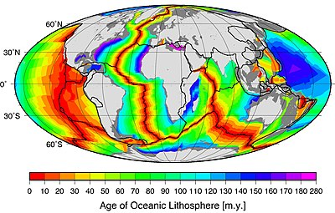
Evidence of Sea Floor Spreading

1.) _________________ ___________________

  - Scientists drilled into the ocean floor

    - ______________ away the sample was
taken from the MOR, the ______________
the rock was

    - _________________ rocks were found at
the center of the__________________

    - The rocks age shows that ______________ ___________ ______________ occurs

**As distance from the ridge________________, ______________ increases

2.) _________________ ___________________
  - Lava contains ___________________________

  - Iron is ________________ (points to magnetic north)

  - When the lava __________________, the iron will be _____________________ in the direction of the magnetic north at the time of the eruption

  - Direction of the iron at the seafloor is __________ _________________ ________ ____________.

  - The patterns are _____________ _________________ on either side

  - Width of stripe indicates ______________ ______________________ the pole was in the normal or reversed position

    - Wider = ____________________
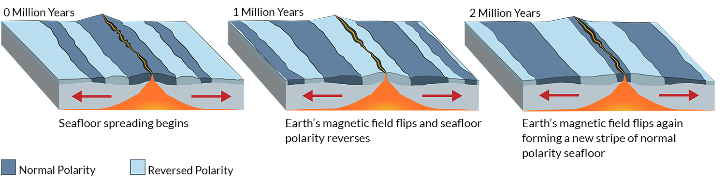

2.) Convergent Boundary-boundary where two plates collide or come together
- __________________ of plates determine which one comes out on top

- Subduction- the process by which _______________ crust sinks beneath a _________________ _____________ ____________ and back into the mantle at a convergent boundary
  - New crust is __________ —less ________________
  - Old crust is ____________ —more ________________
  - __________________________-A deep valley along the ocean floor beneath which oceanic crust slowly sinks toward the mantle
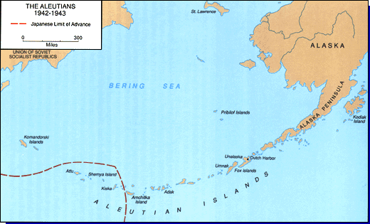
  - __________________ pulls the older, more dense oceanic crust down beneath the __________ into the mantle
Three types of convergent boundaries
- _________________________________

  - the plate that is more ________________ will subduct (sink)
beneath the one that is less dense

  - often forms ___________________________________which
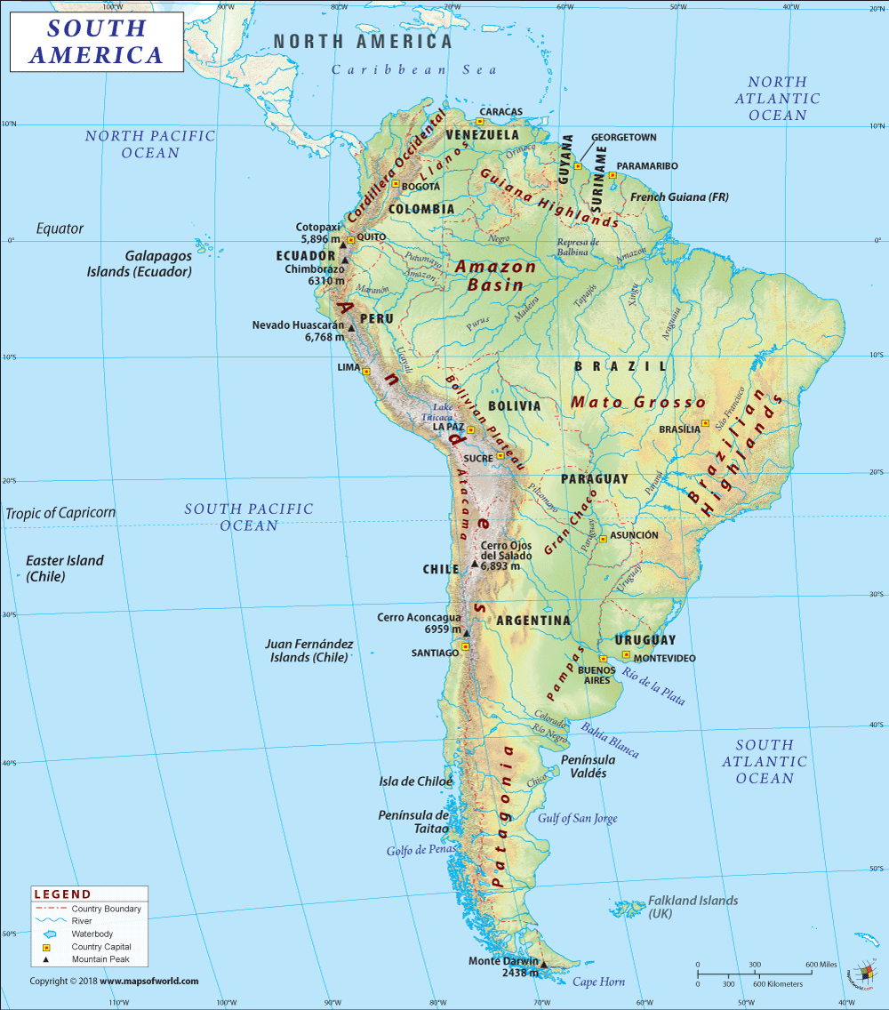
erupt through the overriding plate as the descending plate
melts below it
    - Ex. Aleutian Islands of Alaska

- _________________________________

  - _____________________ crust is more dense so it
will ______________________ below continental

  - Mountains and volcanoes can form-__________________________________
*****Water leaves sinking crust, rises into wedge of mantle above it, the water lowers the
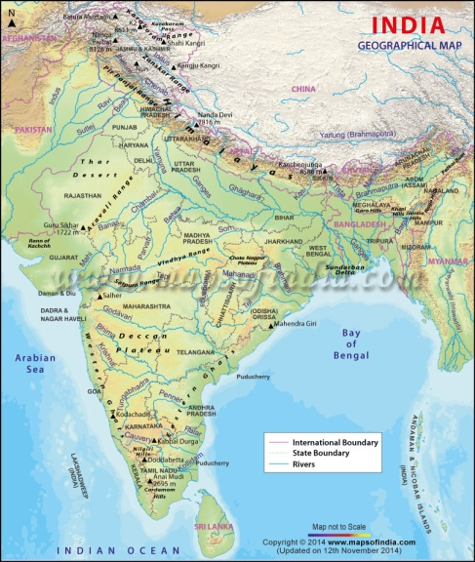
melting point of the mantle, mantle partially melts and volcano forms
    - Ex. __________________________________

***Deep Ocean Trenches generally run ___________________ to volcanic island
arc’s and mountain ranges

- ______________________________-neither is dense enough to sink into
mantle, no __________________, no _________________, mountains form
      - Ex Indian Plate and Eurasian plate collide to form
___________________________
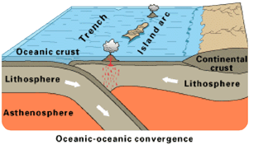
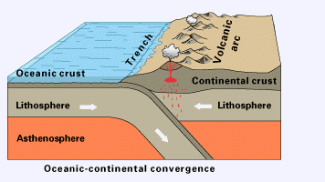
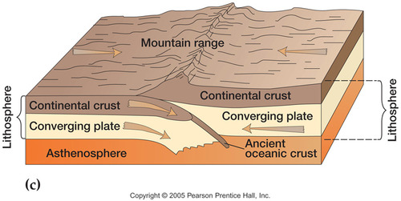

Sea Floor spreading and subduction:
    - _______________ ______________________

    - change the _______________ and _________________ of the oceans

    - They move the ocean floor like a large ___________________ ___________________.

      - Size determined by how fast _____________________ is being created and old crust being s______________________

      - Ocean surrounded by many ___________________—may shrink

      - Ocean with few trenches—will probably grow _________________

3.) Transform Boundary-place where two plates slip past each other, moving in opposite directions.
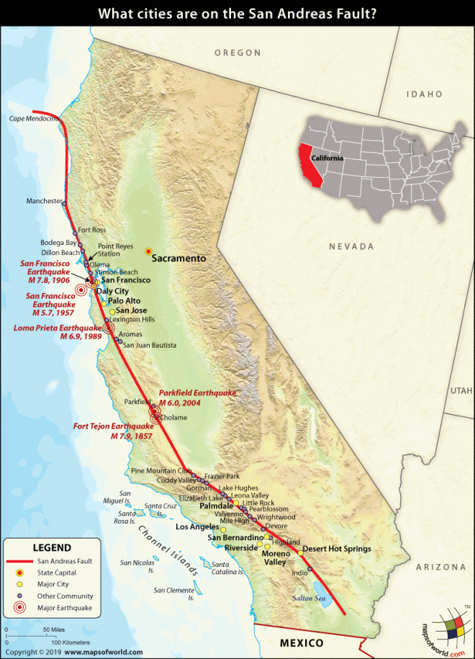
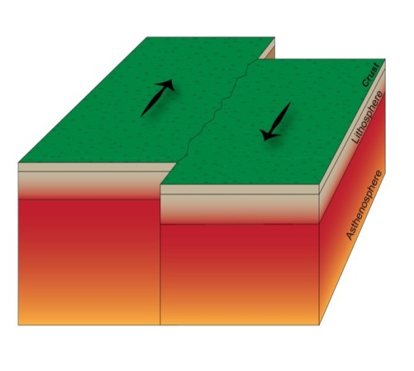
  - Plates are rocky and jagged, and get “stuck”, forces inside Earth cause plates to become “unstuck”, sudden release of energy in the form of an earthquake

    - Crust is neither created nor destroyed.

    - Ex. San Andreas Fault in California

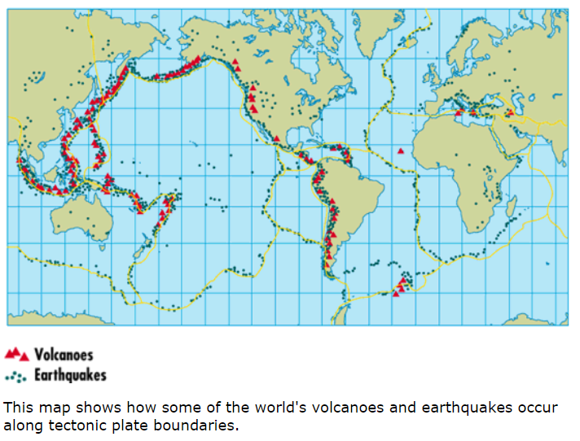
Earthquake and Volcanic Activity

- Most __________________________________ occur because of the
movement of the plates, especially as plates interact at their edges or
boundaries.
- Volcanoes often form where two plates ________________________.

Hot Spots
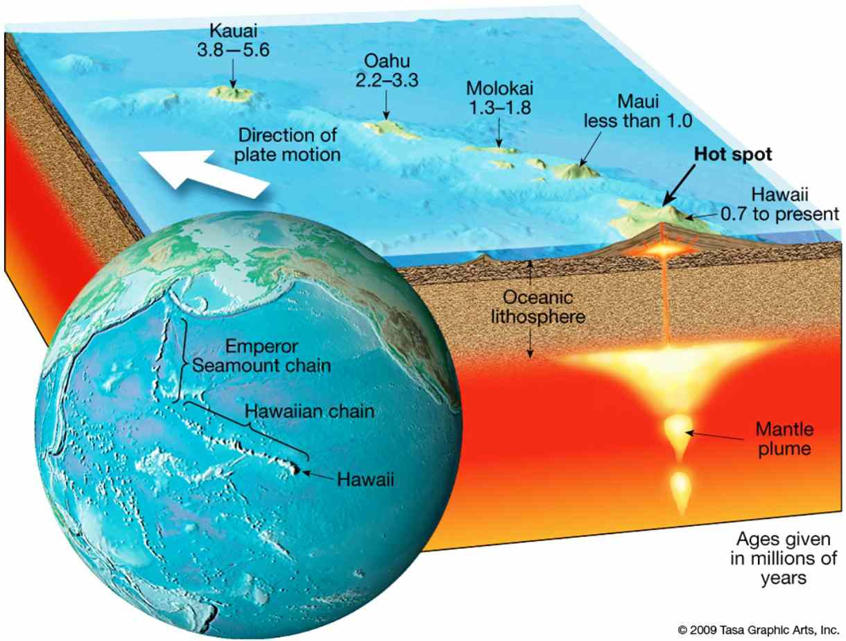
- Sometimes, volcanoes do not occur at plate boundaries
BUT in the middle ____________________________________
    - This is called a _______________________

    - Examples: ______________________, Yellowstone Hot Spot

  - The island over the mantle plume is the ___________________ and
  - the island farthest from the mantle
plume is the ____________________________
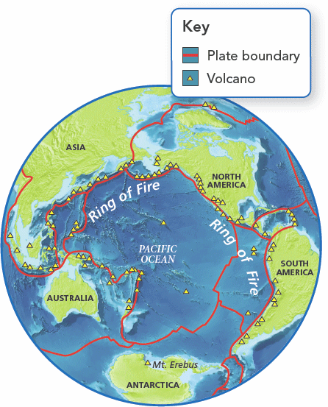
The Ring of Fire

- The world's most active volcanoes lie along what's called
the __________________________________

- Lines the __________________________________

- The "ring" stretches along a _______________-mile (40,000-kilometer)
arc from the boundary of the _____________________, to smaller
plates such as the Philippine Sea plate, to the Cocos and Nazca Plates

- Results in 90% of the world’s _______________________

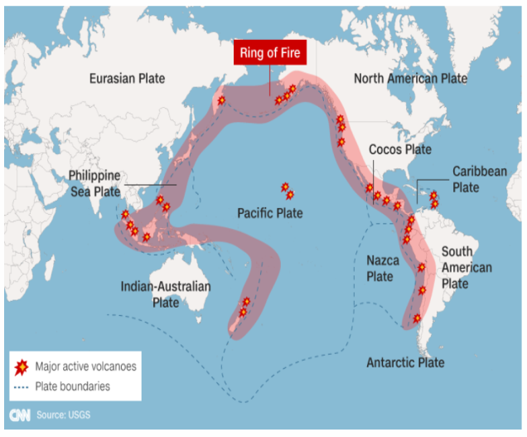
- Home to 75% of the planets ____________________

